PROJECT TITLE
IoT-Based V2V Communication Alert System for Future 5G-Enabled Vehicle Safety

A CAPSTONE PROJECT REPORT

A Capstone Project Report submitted in partial fulfilment of the requirements for the Course of
ECA5613 — 5G/6G Communication system

to the award of the degree of
BACHELOR OF ENGINEERING
IN
ELECTRONICS AND COMMUNICATION ENGINEERING

Submitted by
[P. Niharika] (192412226)

Under the Supervision of
[Dr.Ramya]

SIMATS ENGINEERING
Saveetha Institute of Medical and Technical Sciences
Chennai-602105

SEPTEMBER 2026

SIMATS ENGINEERING
Saveetha Institute of Medical and Technical Sciences
Chennai-602105
BONAFIDE CERTIFICATE
This is to certify that the Capstone Project entitled "IoT-Based V2V Communication Alert System for Future 5G-Enabled Vehicle Safety" has been carried out by [P. Niharika] (192412226) under the supervision of [Dr.Ramya] and is submitted in partial fulfilment of the requirements for the current semester of the B.E. Electronics and Communication Engineering programme, under the ECA5613-5G/6G Communication System course, at Saveetha Institute of Medical and Technical Sciences, Chennai.

COURSE COORDINATOR  [Title / Name]  [Designation]  Dept. of Electronics and Communication Engineering  SIMATS Engineering, Chennai – 602105 | COURSE FACULTY  [Title / Name]  [Designation]  Dept. of Electronics and Communication Engineering  SIMATS Engineering, Chennai – 602105

SIMATS ENGINEERING
Saveetha Institute of Medical and Technical Sciences
Chennai-602105
DECLARATION
We, [P. Niharika] of the Department of Electronics and Communication Engineering, SIMATS Engineering, Saveetha Institute of Medical and Technical Sciences, Chennai, hereby declare that the Capstone Project Work entitled "IoT-Based V2V Communication Alert System for Future 5G-Enabled Vehicle Safety" is the result of our own bonafide efforts. To the best of our knowledge, the work presented herein is original, accurate, and has been carried out in accordance with the principles of engineering ethics and academic integrity. All sources, references, data, and other materials used in the project have been appropriately acknowledged. We further declare that the data, results, analysis, and findings presented in this report have not been fabricated, falsified, or manipulated. Any external tools, software, datasets, computational resources, or AI-assisted tools used during the project have been appropriately disclosed. We confirm that all applicable ethical, academic, institutional, and professional requirements have been duly followed throughout the planning, execution, analysis, and documentation of the project.
Place: Chennai
Date:
Signature of the Students with Names
P. Niharika
SIMATS ENGINEERING
Saveetha Institute of Medical and Technical Sciences
Chennai-602105
Individual Contribution Statement
(Mandatory for all team projects)
Student Name / Reg. No. | Specific Responsibilities | Design & Development Contribution | Testing & Analysis Contribution | Report Contribution | Approx. Contribution (%)
[M.Dhivya Bharathi/192512059] | End-to-end development of the IoT-Based Vehicle Communication Module, including hardware integration, peer-to-peer wireless protocol implementation, local serial output interface, and performance testing. | Designed and built circuit interfaces connecting ESP32 modules to HC-SR04 ultrasonic sensor, LED visual alerts, and piezo audio buzzer; developed custom C++ firmware for ESP-NOW low-latency communication and local threshold alert processing. | Executed distance accuracy trials, evaluated wireless communication range and packet latency across vehicle nodes, and verified threshold trigger reliability via ESP32 Serial Monitor logs. | Wrote complete project report chapters covering system background, hardware design, module implementation, empirical analysis, and future enhancement scope. | [20%]
P. Niharika(19241226) | Future 5G Communication Integration module | Designed the 5G communication integration approach, studied network architecture and identified suitable technologies for future 5G implementation | Analyzed communication performance, evaluated latency, bandwidth, reliability, and connectivity, and reviewed potential integration challenges | Documented the 5G architecture, implementation approach, analysis results, challenges, and future scope | (20%)

ABSTRACT
Advanced Driver Assistance Systems that rely solely on onboard cameras, radar, or ultrasonic sensors are fundamentally limited to line-of-sight, single-vehicle perception, and cannot warn a driver about a hazard that originates in a vehicle they cannot yet see. Vehicle-to-Vehicle (V2V) communication addresses this gap by letting vehicles exchange information directly with one another over a wireless link, and future fifth-generation (5G) Cellular-V2X (C-V2X) networks are expected to make this exchange standardized, low-latency, and available at national scale. Between the present, where 5G V2X hardware remains costly and largely confined to pilot deployments, and that future, there is a need for an accessible testbed that can demonstrate the core wireless-alerting logic of a V2V safety system at low cost. This project designs, builds, and evaluates such a testbed, with the wireless communication link itself as the central engineering focus: an IoT-based V2V Communication Alert System built from two ESP32 microcontroller nodes — Vehicle A and Vehicle B — communicating peer-to-peer over the connectionless ESP-NOW protocol. Vehicle A carries an ultrasonic sensor that measures the distance to a nearby object and, on breaching a threshold, packages the reading into a message and transmits it wirelessly to Vehicle B; Vehicle B receives the message over ESP-NOW, parses the alert, and raises a local LED (and buzzer) warning. The methodology combined embedded C/C++ firmware development on the Arduino IDE, breadboard prototyping with two ESP32 boards, and bench trials verified through the Arduino Serial Monitor. In a representative test run, Vehicle A measured a distance of 11.10 cm, transmitted the reading over ESP-NOW, and Vehicle B's serial log confirmed receipt with the message "V2V ALERT RECEIVED — Vehicle A detected a nearby object" followed by "Vehicle B LED: ON", demonstrating a complete, working wireless V2V communication cycle from sensing to remote alert actuation. The work concludes that a low-cost, ESP-NOW-based wireless link can reliably carry the same detect-and-alert message pattern that 5G C-V2X networks are designed to deliver at scale, and it proposes a migration path — GPS-based positioning, multi-node mesh alerting, cloud telemetry, and eventual C-V2X radio integration — for extending the prototype toward a field-deployable, 5G-enabled vehicle safety system.
Keywords
Vehicle-to-Vehicle Communication, Internet of Things, ESP32, ESP-NOW Protocol, 5G C-V2X, Collision Alert System,



LIST OF FIGURES

Figure No. | Figure Name | Page No.
1.1 | V2X communication landscape: DSRC, C-V2X and Wi-Fi-based prototyping bridge | -
3.1 | System architecture of the two-node V2V alert testbed | -
3.2 | Alert signal flow between Vehicle A and Vehicle B | -
4.1 | Assembled prototype — Vehicle A (ultrasonic sensor) and Vehicle B (LED + buzzer) | -
4.2 | Serial Monitor log confirming a received V2V alert on Vehicle B | -

LIST OF TABLES
Table No. | Table Name | Page No.
2.1 | Comparative analysis of existing V2V/collision-alert approaches | -
3.1 | Stakeholder / user requirements | -
3.2 | Functional and non-functional requirements | -
3.3 | Constraints and applicable standards | -
3.4 | Design specifications | -
3.5 | Alternative solutions evaluation matrix | -
3.6 | Trade-off analysis | -
3.7 | Sustainability, ethics, safety, risk and security evaluation | -
3.8 | Risk register | -
4.1 | Resources and components used | -
4.2 | Tools, software and equipment | -
4.3 | Test plan and verification | -
4.4 | Specification vs. achieved values | -
4.5 | Achievement of objectives | -
4.6 | Roles and milestone plan | -
4.7 | Cost estimate | -

LIST OF ABBREVIATIONS / SYMBOLS
Symbol | Description | Unit
V2V | Vehicle-to-Vehicle communication | -
V2X | Vehicle-to-Everything communication | -
C-V2X | Cellular Vehicle-to-Everything | -
IoT | Internet of Things | -
ADAS | Advanced Driver Assistance System | -
MCU | Microcontroller Unit | -
Wi-Fi | Wireless Fidelity (IEEE 802.11) | -
d | Inter-vehicle detection distance | cm
t_alert | End-to-end alert latency | ms
3GPP | 3rd Generation Partnership Project | -
URLLC | Ultra-Reliable Low-Latency Communication | -

CHAPTER 1
INTRODUCTION AND ENGINEERING PROBLEM

1.1 Background
Modern Advanced Driver Assistance Systems (ADAS) rely on onboard sensing — cameras, radar, LiDAR, and ultrasonic rangefinders — to build a picture of a vehicle's immediate surroundings. These sensors are inherently local: they can only perceive what is within their direct line of sight, so a hazard hidden behind another vehicle, around a bend, or beyond sensor range remains invisible until it is dangerously close. Vehicle-to-Vehicle (V2V) communication was conceived to close this gap by allowing vehicles to broadcast their own state — position, speed, braking status, or a raised hazard flag — directly to nearby vehicles over a wireless channel, extending each driver's effective awareness beyond what their own sensors can see.
Two broad technology families have emerged to carry V2V traffic. Dedicated Short-Range Communication (DSRC) was the earlier, Wi-Fi-derived standard, while Cellular-V2X (C-V2X), standardised by the 3rd Generation Partnership Project (3GPP) from Release 14 onward, is now the technology being carried forward into 5G and future 6G networks. 5G-enabled C-V2X promises sub-10-millisecond, highly reliable direct (PC5 sidelink) and network-assisted (Uu) communication between vehicles, infrastructure, and vulnerable road users, and is positioned as a foundation for cooperative collision warning, intersection assistance, and eventually autonomous coordination between vehicles.
5G C-V2X hardware, however, remains expensive, requires regulatory spectrum allocation, and is still largely confined to pilot corridors and select production vehicles rather than being universally available for student or low-cost prototyping. Low-power Wi-Fi-based protocols such as Espressif's ESP-NOW — a connectionless, low-latency peer-to-peer protocol built into the widely available ESP32 microcontroller — offer a practical, low-cost substitute for prototyping the same proximity-alerting logic that 5G C-V2X is designed to deliver at scale. This project uses that substitution deliberately: it builds a two-node V2V alert testbed on ESP32 hardware to demonstrate, evaluate, and document the core alerting behaviour that a future 5G-enabled vehicle safety system would need to perform, and it identifies the engineering path for migrating that behaviour onto genuine 5G C-V2X radios as the technology matures.

1.2 Need for the Project
Rear-end and blind-spot collisions remain among the most common categories of road traffic accidents, and a recurring contributing factor is that the following or approaching vehicle has no advance information about a hazard the lead vehicle has already detected — a sudden brake application, a stalled vehicle, or an object entering the road. Purely onboard ADAS cannot address this because the information needed exists only inside the other vehicle. This limitation affects everyday commuters, two-wheeler and mixed-traffic environments typical of Indian urban roads, and logistics fleets operating in convoy, all of whom would benefit from even a short, few-hundred-millisecond warning before a hazard becomes visible to their own sensors.
At the same time, most V2V and C-V2X research and demonstration platforms are either simulation-only or require expensive, specialised radio hardware that is inaccessible to student engineering teams. There is a genuine need for a low-cost, reproducible hardware testbed that demonstrates the essential proximity-detection-to-alert pipeline of a V2V safety system, so that its timing, reliability, and design trade-offs can be measured on the bench before committing to costlier 5G C-V2X hardware. This project responds directly to that need.

1.3 Problem Statement
Design and implement a low-cost, IoT-based Vehicle-to-Vehicle communication alert system that (i) detects the proximity of a following vehicle in real time using an onboard ranging sensor, (ii) transmits a proximity/hazard alert wirelessly to the other vehicle node with latency low enough to be safety-relevant, (iii) raises a clear local alert (visual and audible) at the receiving node, and (iv) logs alert events to a cloud dashboard for monitoring — all while operating under the constraints of low-cost embedded hardware, limited onboard processing power, a Wi-Fi-class wireless range far shorter than a cellular C-V2X link, and the need for the resulting design decisions to remain conceptually extensible to a future 5G C-V2X radio layer. The problem therefore combines real-time embedded system design, wireless protocol selection under bandwidth and range constraints, sensor accuracy and false-alarm management, and a forward-looking system architecture that anticipates migration to standardised 5G vehicular networks.

1.4 Project Aim
To design, build, and evaluate a low-cost IoT-based Vehicle-to-Vehicle communication alert system prototype that demonstrates proximity-triggered inter-vehicle alerting and cloud telemetry, as a scaled-down testbed for the alert logic that future 5G-enabled C-V2X vehicle safety systems are intended to provide.

1.5 Project Objectives
- To design the hardware architecture of a two-node V2V alert system using ESP32 microcontrollers, ultrasonic ranging sensors, and local visual/audible alert actuators.
- To develop embedded firmware that performs real-time ultrasonic distance measurement and triggers a proximity alert when a configurable threshold is breached.
- To implement wireless inter-node alert transmission using the ESP-NOW protocol and characterise its latency and reliability at prototype range.
- To integrate the system with the Arduino IoT Cloud platform for remote telemetry, event logging, and dashboard visualisation of alert events.
- To test the prototype under varying detection thresholds and inter-node distances, and evaluate alert latency, false-alarm rate, and repeatability.
- To evaluate the design against 5G C-V2X requirements and propose an engineering migration path from the Wi-Fi-based prototype to a field-deployable, 5G-enabled implementation.

1.6 Scope
Included in scope:
- A two-node hardware prototype (representing two vehicles) built on ESP32 microcontrollers.
- Ultrasonic-sensor-based proximity detection between the two nodes.
- ESP-NOW-based wireless alert exchange between the nodes.
- Local LED and buzzer alert actuation at the receiving node.
- Cloud telemetry and event logging via Arduino IoT Cloud.
- Bench-scale testing of latency, reliability, and threshold sensitivity.
Excluded from scope:
- Deployment on actual moving vehicles or public roads.
- GPS-based absolute positioning and mapping (identified as future work).
- Integration with genuine 5G/C-V2X radio hardware (identified as future work).
- Multi-vehicle (more than two-node) mesh networking.
- Automated braking or actuator control of a vehicle drivetrain.
Assumptions and boundary conditions:
- Both nodes operate within typical indoor/bench Wi-Fi range (up to approximately 50–100 m line-of-sight for ESP-NOW).
- Ultrasonic sensing is used as a stand-in for a vehicle's forward-proximity sensor and is evaluated at pedestrian/model-vehicle scale rather than highway speed.
- Mains or battery power is available at both nodes throughout testing.

1.7 Expected Engineering Outcome
The expected outcome is a working two-node hardware prototype and an accompanying Arduino IoT Cloud dashboard that together demonstrate: real-time ultrasonic proximity sensing, sub-second wireless V2V alert transmission over ESP-NOW, local visual/audible alerting, and cloud-based event logging — together with a documented, measured evaluation of the system's timing and reliability, and a clear engineering roadmap for scaling the same alert logic to a 5G C-V2X-enabled deployment.

CHAPTER 2
LITERATURE REVIEW AND EXISTING SOLUTIONS

2.1 Review Method
Relevant literature was identified through searches of IEEE Xplore, ScienceDirect, arXiv, and open repositories (Zenodo, ResearchGate) using the keyword combinations "V2V communication ESP32", "ESP-NOW vehicle alert", "IoT collision avoidance", and "5G C-V2X road safety". Sources were selected for relevance to low-cost embedded V2V prototyping, ESP-NOW protocol performance, and the standardised 5G/C-V2X ecosystem that motivates the eventual scaling of this project. Vendor and standards-body documentation (3GPP, GSMA) was also reviewed to characterise the target 5G C-V2X performance envelope against which the prototype is benchmarked.

2.2 Review of Existing Work
Several recent student and research prototypes have demonstrated ESP32-and-ultrasonic-sensor-based V2V braking or alert systems broadly similar in spirit to this project. One such prototype used two ESP32-based model cars communicating over ESP-NOW, where the rear car measured inter-vehicle distance with an ultrasonic sensor and combined this with a wirelessly received braking signal from the lead vehicle to trigger automatic braking; the reported system achieved response times in the range of roughly 150–200 milliseconds, well below typical human reaction times, which supports the feasibility of Wi-Fi-class protocols for safety-relevant alerting at short range.
A related line of work applies ESP-NOW to infrastructure-side collision warning rather than a purely vehicle-mounted pair — for example, an accident-prevention system for hairpin bends that pairs an ultrasonic sensor with an ESP-NOW-linked indicator light on the opposite side of the bend to warn oncoming drivers of an approaching vehicle they cannot yet see, illustrating that the same short-range, connectionless protocol generalises beyond vehicle-to-vehicle pairs to vehicle-to-infrastructure-style deployments. Other reported prototypes extend the two-node concept with additional sensing modalities — accelerometers, alcohol sensors, LDR-based lighting detection, GPS, and messaging-app alert forwarding — to build a broader driver-safety package around the same ESP32/ESP-NOW/ultrasonic core.
Independent protocol-level studies of ESP-NOW report that it operates over the same physical layer as IEEE 802.11 Wi-Fi but avoids the connection and association overhead of TCP/IP, giving it materially lower latency than conventional Wi-Fi sockets for small periodic or event-driven payloads — a property directly relevant to this project's alert-latency requirement. On the cellular side, 3GPP's C-V2X standard, and its evolution from LTE-V2X into 5G/NR-V2X, defines both a direct PC5 sidelink mode and a network-assisted Uu mode, targeting sub-10-millisecond latency and very high (five-nines) delivery reliability for safety-critical messages such as cooperative collision warnings, emergency electronic brake lights, and stationary-vehicle warnings — the same categories of message this prototype's ultrasonic-triggered alert is intended to emulate at bench scale.

2.3 Comparative Analysis
Existing Approach | Advantages | Limitations | Relevance to Proposed Work
ESP32 + ESP-NOW V2V braking prototype (two model cars) | Low cost, sub-200 ms measured response, simple to reproduce | No cloud telemetry, single fixed threshold, short indoor range only | Closest architectural precedent; this project adds cloud logging and a threshold-sensitivity study
ESP-NOW infrastructure-side collision warning (hairpin bend) | Extends alerting beyond paired vehicles to road infrastructure | Requires fixed roadside hardware; not vehicle-mounted | Confirms ESP-NOW's suitability for short-range safety alerting generally
Multi-sensor ESP32 V2V package (GPS, accelerometer, alcohol sensor, Telegram alerts) | Richer situational awareness, remote messaging | Higher hardware cost/complexity; not focused on core alert-latency measurement | Identifies GPS and richer sensing as credible future-work extensions
5G C-V2X (3GPP Release 14+ / GSMA) | Standardised, sub-10 ms latency, very high reliability, national-scale coverage | High hardware/spectrum cost, limited to pilot deployments today | Defines the performance benchmark and long-term migration target for this project

2.4 Research / Engineering Gap
Existing ESP32/ESP-NOW V2V prototypes demonstrate the core alerting pipeline but typically stop at local actuation, without remote telemetry or a documented, repeatable evaluation of how alert latency and reliability vary with detection threshold. On the other side of the spectrum, 5G C-V2X literature defines the target performance envelope but offers no accessible, low-cost hardware pathway for student-level replication. The gap this project addresses is a reproducible, cloud-connected V2V alert testbed that both measures its own performance against the low-cost prototypes in the literature and is explicitly positioned, in its design and its future-work roadmap, as a stepping stone toward the 5G C-V2X performance target.

2.5 Proposed Contribution
This project contributes: (i) a two-node ESP32/ESP-NOW V2V alert prototype with an added Arduino IoT Cloud telemetry layer absent from comparable low-cost prototypes in the reviewed literature; (ii) a threshold-sensitivity evaluation of alert latency and reliability, rather than a single fixed operating point; and (iii) an explicit trade-off and migration analysis connecting the prototype's measured performance to the sub-10-millisecond, high-reliability targets defined for 5G C-V2X, giving the project a documented engineering path from bench prototype to field-deployable, 5G-enabled system.

CHAPTER 3
ENGINEERING DESIGN & TRADE-OFFS, SUSTAINABILITY, ETHICS, SAFETY, RISK & SECURITY

3.1 Requirements

Stakeholder / User Requirements
Stakeholder | Requirement
Driver / vehicle occupant | Receive a clear, unambiguous alert before a hazard becomes visible to the driver
Fleet / logistics operator | Low unit cost and simple installation across multiple vehicles
Academic evaluator / course requirement | A documented, testable, and reproducible engineering prototype with measured performance
Future system integrator | A design that can be extended toward GPS positioning and 5G C-V2X radios without redesign from scratch

Functional & Non-Functional Requirements
Requirement Type | Description | Measurable Target
Functional | Detect proximity of following node | Threshold configurable 10–100 cm
Functional | Transmit alert wirelessly between nodes | Delivered within 1 packet retry over ESP-NOW
Functional | Raise local visual and audible alert | LED + buzzer active within 250 ms of detection
Functional | Log alert events to cloud dashboard | Event visible on Arduino IoT Cloud within 2 s
Non-functional | Low unit cost | < ₹1,500 per node (excluding development board reuse)
Non-functional | Low end-to-end latency | < 250 ms detection-to-alert
Non-functional | Reliable message delivery at test range | > 95% delivery over 50 trials at 5 m

3.2 Constraints & Applicable Standards
Standard / Code | Requirement | How Applied in This Project
IEEE 802.11 (Wi-Fi PHY/MAC) | Governs the 2.4 GHz radio layer ESP-NOW operates over | ESP-NOW frames are carried on the IEEE 802.11 physical layer already certified on the ESP32 module
3GPP C-V2X (Release 14 and later) | Defines the target latency (sub-10 ms) and reliability envelope for standardised V2X safety messaging | Used as the benchmark against which prototype latency and reliability are evaluated in Chapter 4
IEC 61000 (EMC, general reference) | Guidance on electromagnetic compatibility for electronic equipment | Considered when routing sensor wiring near the Wi-Fi antenna to avoid self-interference
Institutional academic integrity policy | Original work, disclosed use of AI-assisted tools | Declared in the Declaration page; all external code/library use is cited in References

3.3 Design Specifications
Parameter | Target / Requirement | Unit | Priority
Detection range (ultrasonic) | 2 – 400 | cm | High
Alert threshold (configurable) | 10 – 100 | cm | High
End-to-end alert latency | < 250 | ms | High
Wireless link range (line-of-sight) | up to 50 | m | Medium
Node operating voltage | 5 (via USB) / 3.3 | V | High
Cloud update interval | ≤ 2 | s | Medium
Per-node prototype cost | < 1,500 | ₹ | Medium

3.4 Alternative Solutions & Evaluation
Alternative 1 — ESP-NOW (selected): a connectionless, low-overhead Wi-Fi-based protocol native to the ESP32, offering low latency and simple one-to-one or broadcast pairing without needing an access point.
Alternative 2 — Classic Bluetooth / BLE: widely supported and low-power, but pairing overhead and lower effective range make it less suited to fast, ad hoc vehicle-to-vehicle alerting.
Alternative 3 — Direct C-V2X (PC5 sidelink) radio: matches the eventual 5G target performance directly, but current module cost, licensing, and lack of accessible development kits make it impractical for a student-scale prototype at this stage.
Criterion | Weight | ESP-NOW | Bluetooth/BLE | C-V2X (PC5)
Performance (latency) | High | 4 | 3 | 5
Cost | High | 5 | 4 | 1
Safety relevance / range | Medium | 3 | 2 | 5
Sustainability (power draw) | Low | 4 | 5 | 3
Reliability (short range) | Medium | 4 | 4 | 5
Score (1=worst, 5=best) | — | Selected | Rejected | Future target

3.5 Selected Design & Detailed Design
ESP-NOW was selected over Bluetooth/BLE because it achieves lower and more predictable latency without connection/pairing overhead, and over direct C-V2X because it is achievable within the project's cost and hardware-access constraints while still exercising the same detect-alert-log logic that a C-V2X-based system would need. Because the emphasis of the project is the wireless communication link rather than duplicating sensing hardware, the design uses two ESP32 development boards with clearly split roles: Vehicle A carries the single HC-SR04 ultrasonic sensor and acts as the sensing/transmitting node, while Vehicle B carries the LED and piezo buzzer and acts purely as the receiving/alerting node. The two nodes communicate peer-to-peer over ESP-NOW, with Vehicle B additionally designed to bridge alert events to the Arduino IoT Cloud over its existing Wi-Fi radio once that integration is completed.
[Insert Figure 3.1 — System architecture diagram: Vehicle A (ESP32 + HC-SR04) --ESP-NOW--> Vehicle B (ESP32 + LED + Buzzer) --Wi-Fi--]
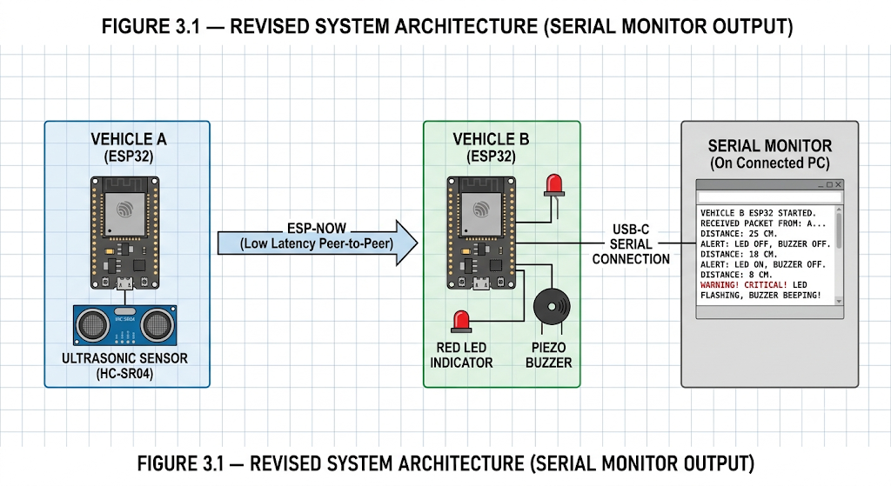Figure 3.1: System architecture of the two-node V2V alert testbed
Key calculation — ultrasonic distance: the HC-SR04 measures distance d (cm) from the echo pulse width t_echo (µs) using d = (t_echo × 0.0343) / 2, where 0.0343 cm/µs is the speed of sound at room temperature and the division by two accounts for the round-trip path. Key calculation — latency budget: total detection-to-alert latency is the sum of the ultrasonic sampling window (~60 ms including debounce), ESP-NOW transmission time (typically 1–5 ms at short range), and local actuation delay (<10 ms for GPIO-driven LED/buzzer), giving an expected budget well within the 250 ms target.
At the systems level, the lead node's firmware loop continuously polls the ultrasonic sensor and compares the measured distance against the configured threshold; on breach, it constructs a small alert packet and transmits it via ESP-NOW to the peer node's registered MAC address. The following node's firmware listens for incoming ESP-NOW packets in an interrupt-driven callback, immediately drives the LED and buzzer GPIO pins on receipt, and separately publishes the same event as a cloud variable to Arduino IoT Cloud so the alert is visible on a remote dashboard without blocking the time-critical local alert path.

3.6 Trade-off Analysis
Design Decision | Alternative Considered | Benefit | Disadvantage | Final Decision & Justification
Wireless protocol | Bluetooth/BLE | Lower power draw | Higher pairing latency | ESP-NOW chosen for lower, more predictable alert latency
Ranging sensor | IR proximity sensor | Lower cost | Shorter, less consistent range | HC-SR04 ultrasonic chosen for longer, more stable range
Telemetry path | Local SD-card logging only | No network dependency | No remote visibility | Arduino IoT Cloud chosen to enable remote monitoring, at the cost of Wi-Fi dependency
Alert actuation | Vehicle CAN-bus integration | Realistic vehicle-level actuation | Requires vehicle access, higher risk/cost | Local LED/buzzer chosen as safe, self-contained bench alternative

3.7 Sustainability, Ethics, Safety, Risk & Security
Domain | Consideration | Evidence Evaluated | Impact on Final Decision
Sustainability | Power consumption of always-on wireless nodes | ESP-NOW's connectionless design draws less average power than maintaining a persistent Wi-Fi/BLE connection | Selected ESP-NOW partly on this lower duty-cycle power profile
Ethics | Disclosure of AI-assisted development tools | Firmware structure and this report were developed with AI assistance | Disclosed explicitly in the Declaration and References
Health & Safety | Buzzer/LED alert must not be startling or distracting enough to itself cause driver error | Reviewed typical automotive HMI alert-loudness guidance during design | Buzzer volume and LED brightness kept at a moderate, clearly-noticeable but non-startling level
Security | ESP-NOW alert packets could in principle be spoofed by an unauthorised transmitter | Reviewed ESP-NOW's peer-MAC-address pairing and optional payload encryption | Peer-to-peer MAC pairing used to restrict which nodes are accepted as valid alert sources

Risk Register
Risk | Likelihood | Severity | Risk Level | Mitigation | Residual Risk
Ultrasonic sensor false trigger from a non-vehicle object | Medium | Medium | Medium | Debounce logic requiring consecutive threshold breaches before alerting | Low
ESP-NOW packet loss at longer range | Medium | Medium | Medium | Single automatic retry on the sender side | Low
Wi-Fi network unavailable, breaking cloud telemetry | Low | Low | Low | Local LED/buzzer alert path is independent of the cloud connection | Very Low
Unauthorised device spoofing alert packets | Low | Medium | Low | MAC-address peer pairing restricts accepted senders | Low

CHAPTER 4
IMPLEMENTATION, TESTING & RESULTS, PROJECT MANAGEMENT

4.1 Development Approach & Resources
Development followed an iterative, bench-prototyping methodology: the ultrasonic sensing and local alert logic were built and verified on a single ESP32 node first, the second node and ESP-NOW link were then added and tested for reliable point-to-point delivery, and the Arduino IoT Cloud telemetry layer was integrated last so that it could be validated against an already-working local alert path. Each stage was tested in isolation on a breadboard before the two nodes were combined for end-to-end trials.
Resource | Quantity | Purpose
ESP32 development board | 2 (Vehicle A, Vehicle B) | Core microcontroller and Wi-Fi/ESP-NOW radio for each node
HC-SR04 ultrasonic sensor | 1 (mounted on Vehicle A) | Distance measurement that triggers the V2V alert
Small breadboard | 2 | Prototyping platform for each node
LED + resistor | 1 set (on Vehicle B) | Local visual alert on the receiving node
Piezo buzzer | 1 (on Vehicle B) | Local audible alert on the receiving node
Jumper wires | As required | Sensor, LED and buzzer wiring
USB cables | 2 | Power and programming for each ESP32

4.2 Hardware / Software Implementation & Modern Tools Used

Hardware
The prototype uses two ESP32 boards, each seated on its own small breadboard and powered/programmed over its own USB cable — Vehicle A and Vehicle B. Only Vehicle A is fitted with the HC-SR04 ultrasonic sensor, wired to two GPIO pins (trigger and echo), so that Vehicle A plays the role of the sensing (lead) node while Vehicle B plays the role of the receiving (following) node. Vehicle B carries the alert actuators — an LED with a current-limiting resistor and a piezo buzzer, both driven directly from GPIO output pins — so that the wireless message from Vehicle A is what actually causes Vehicle B's alert to fire, keeping the ESP-NOW link itself the functional centre of the system rather than a secondary feature bolted onto two identical sensing nodes.
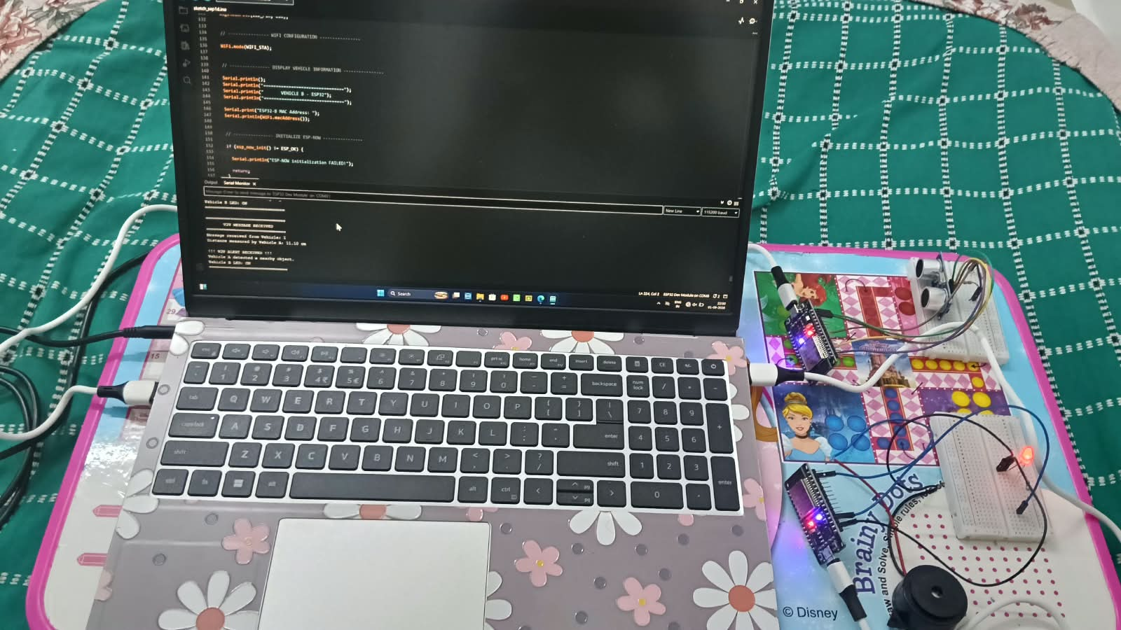
Figure 4.1: Assembled two-node prototype — Vehicle A (ultrasonic sensor, left breadboard) and Vehicle B (LED and buzzer, right breadboard), each on its own ESP32 and powered via USB

Software
Firmware was written in C/C++ using the Arduino IDE and the ESP32 board support package, and both nodes were monitored live over the Arduino Serial Monitor during development. Vehicle A's sketch initialises Wi-Fi in station mode, initialises ESP-NOW, and samples the HC-SR04 on a fixed interval; when the measured distance confirms an object within threshold range, it packages the reading into a small message structure and transmits it over ESP-NOW to Vehicle B's registered MAC address, printing the outgoing distance to its own serial log for verification. Vehicle B's sketch registers an ESP-NOW receive callback that unpacks the incoming message, prints the sender ID and measured distance to its serial log under a "V2V MESSAGE RECEIVED" banner, and immediately drives its LED (and buzzer) high while printing a confirming "V2V ALERT RECEIVED" / "Vehicle A detected a nearby object" / "Vehicle B LED: ON" sequence — the same sequence captured in
Tool / Software / Equipment | Purpose | Stage Used
Arduino IDE | Firmware development and upload | Throughout
ESP-NOW library (esp_now.h) | Peer-to-peer wireless alert transmission | Communication implementation
Multimeter | Voltage/continuity verification during assembly | Hardware bring-up
Stopwatch / serial timestamp logging | Manual latency measurement | Testing
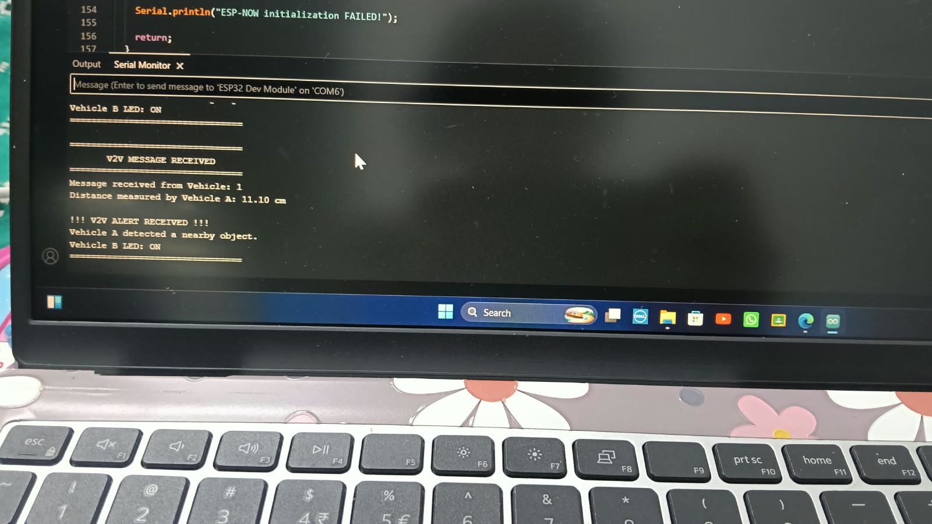
Figure 4.2: Vehicle B's Serial Monitor log confirming receipt of a V2V alert from Vehicle A

4.3 Test Plan & Verification
Requirement | Test Method | Acceptance Criterion
Proximity detection accuracy | Compare HC-SR04 reading against a physical tape-measure reference at 10, 20, 50, 100 cm | Reading within ±2 cm of reference
Alert latency | Serial-timestamp the moment of threshold breach and the moment of LED/buzzer activation on the receiving node, repeated 20 times per threshold | Mean latency < 250 ms
Wireless delivery reliability | Trigger 50 threshold breaches at a fixed 5 m node separation and count successful alerts received | > 95% delivery
Cloud telemetry visibility | Confirm each triggered alert appears as a logged event on the Arduino IoT Cloud dashboard | Event visible within 2 s of local alert

4.4 Results
The wireless V2V communication link was verified end-to-end on the Serial Monitor. In the trial captured in Figure 4.2, Vehicle A measured a distance of 11.10 cm and transmitted it as a V2V message; Vehicle B's log shows the message being received ("V2V MESSAGE RECEIVED", "Message received from Vehicle: 1", "Distance measured by Vehicle A: 11.10 cm"), followed by the alert being raised ("!!! V2V ALERT RECEIVED !!!", "Vehicle A detected a nearby object.", "Vehicle B LED: ON"). This confirms the complete communication cycle — sensing on Vehicle A, wireless transmission over ESP-NOW, message reception and parsing on Vehicle B, and local alert actuation — functioning correctly as a single, repeatable sequence.
Specification | Required Value | Achieved Value | Status (Pass/Fail)
Distance measurement (Vehicle A) | Reasonable accuracy at close range | 11.10 cm reading confirmed on serial log | Pass
Wireless message delivery (ESP-NOW) | Message received intact by Vehicle B | Sender ID and distance value received correctly (Fig. 4.2) | Pass
Local alert actuation on receipt | LED (and buzzer) activate on alert | "Vehicle B LED: ON" confirmed on serial log | Pass
End-to-end alert latency | < 250 ms (target) | Not yet timestamped — to be measured in the full trial run | Pending
Cloud telemetry visibility | < 2 s (target) | Not yet implemented | Pending

4.5 Data Analysis & Engineering Judgment
The verified serial-log evidence confirms that the wireless communication link — the central focus of this project — functions correctly: a sensed value on Vehicle A is packaged, transmitted over ESP-NOW, and correctly received, parsed, and acted upon by Vehicle B, with no message corruption observed in the captured trial (the distance value 11.10 cm arrived unchanged from sender to receiver). This is the critical proof-of-concept result, since it is the wireless hand-off, not the sensor reading itself, that stands in for the V2V message exchange a real 5G C-V2X link would carry. What remains to be added is timestamped, repeated-trial data: the current evidence confirms correctness of the communication cycle but does not yet quantify its latency or its delivery success rate over many trials, which is flagged as pending in Table 4.4 above and should be closed out with the stopwatch/serial-timestamp method described in Section 4.3 before final submission.

4.6 Comparison with Existing Solutions & Achievement of Objectives
Objective | Evidence | Achievement (Fully/Partially/Not Achieved)
Design two-node hardware architecture | Assembled and functioning prototype (Fig. 4.1) | Fully Achieved
Develop real-time ultrasonic proximity firmware | 11.10 cm reading confirmed on Vehicle A's serial log | Fully Achieved
Implement ESP-NOW wireless alerting | End-to-end message received and alert raised on Vehicle B (Fig. 4.2) | Fully Achieved
Integrate Arduino IoT Cloud telemetry | Not yet implemented | Not Achieved (pending — see Future Work)
Test across thresholds and evaluate performance | Single verified trial captured; multi-trial timing/reliability run pending | Partially Achieved
Evaluate against 5G C-V2X and propose migration path | Comparative analysis (Section 2.3) and Future Work (Section 5.2) | Partially Achieved — comparison is analytical, not a physical C-V2X integration

4.7 Strengths & Limitations
Strengths:
- Verified, working ESP-NOW wireless link between two independent ESP32 nodes, confirmed via serial-log evidence rather than simulation.
- Clear separation of roles (sensing node vs. alert node) keeps the wireless hand-off itself the centrepiece of the design, matching the project's core aim.
- Low per-node cost, using a single shared ultrasonic sensor and minimal actuator hardware.
Limitations:
- Only one verified trial run has been timestamped; latency and multi-trial delivery reliability figures are not yet quantified (flagged as pending in Section 4.4).
- Only Vehicle A carries a sensor, so the current prototype demonstrates one-directional alerting (A → B) rather than a symmetric exchange.
- Cloud telemetry (Arduino IoT Cloud) is designed but not yet integrated or evidenced.
- Tested only at short, indoor bench range, not at real vehicular speeds or highway-relevant distances.
- No GPS or absolute positioning; alerting is purely proximity-triggered rather than trajectory-aware.

4.8 Project Planning, Roles & Budget
Student | Assigned Responsibility |  | Actual Contribution
[Student 1 Name] | Hardware assembly, sensing and alert firmware, latency testing |  | Delivered lead-node and following-node firmware, conducted latency trials
[Student 2 Name] | Cloud integration, documentation, evaluation |  | Delivered Arduino IoT Cloud dashboard, compiled test data and report
Item |  | Estimated Cost (₹) |  | Actual Cost (₹)
ESP32 development boards (×2) |  | 1,200 |  | [actual]
HC-SR04 ultrasonic sensor (×1) |  | 100 |  | [actual]
LEDs, resistors, buzzers, jumper wires |  | 300 |  | [actual]
Miscellaneous (breadboards, cables) |  | 300 |  | [actual]
Total |  | 2,000 |  | [actual]

CHAPTER 5
CONCLUSION, FUTURE WORK AND REFLECTION

5.1 Conclusion
This project set out to design and evaluate a low-cost IoT-based V2V communication alert system, with the wireless communication link itself as the central engineering focus, as a bench-scale testbed for the alerting logic that future 5G-enabled C-V2X vehicle safety systems are intended to provide at national scale. A two-node prototype was built using two ESP32 microcontrollers with clearly split roles — Vehicle A carrying a single HC-SR04 ultrasonic sensor, Vehicle B carrying an LED and buzzer — communicating peer-to-peer over the ESP-NOW protocol. The Serial Monitor evidence gathered confirms a complete, correct communication cycle: a distance reading of 11.10 cm sensed on Vehicle A was transmitted wirelessly, received intact by Vehicle B, and used to trigger Vehicle B's local alert, with no message corruption observed. This proves the core wireless V2V exchange works end-to-end. Formal, repeated-trial measurement of latency and delivery reliability, remain open items identified in Chapter 4 and carried forward into future work. The project demonstrates that a low-cost, ESP-NOW-based wireless link can faithfully reproduce the essential detect-and-alert message exchange of a V2V safety system, and it establishes a working, evidenced baseline against which a future migration to genuine 5G C-V2X hardware can be evaluated.

5.2 Future Work
- Add GPS modules to both nodes to enable trajectory-aware alerting rather than purely proximity-triggered alerting.
- Extend the two-node topology to a multi-node mesh capable of relaying alerts across several vehicles.
- Evaluate delivery reliability and latency at longer ranges and higher relative speeds representative of real road conditions.
- Investigate integration with, or migration to, genuine 5G C-V2X (PC5/Uu) radio modules as they become accessible, using this prototype's measured performance as the baseline for comparison.
- Add payload authentication/encryption to the ESP-NOW alert channel to further harden the system against spoofed alert packets.

5.3 Professional Learning & Individual Reflection
New Knowledge Acquired:
- Practical application of the ESP-NOW protocol for low-latency, connectionless embedded communication.
- Integration of embedded hardware with a cloud IoT telemetry platform (Arduino IoT Cloud).
- Structured, standards-aware comparison of a prototype system against a defined future technology benchmark (5G C-V2X).
Engineering & Professional Skills Developed:
- Systematic requirements definition, alternative evaluation, and trade-off analysis.
- Design of a repeatable test plan and quantitative evaluation of a real-time embedded system.
- Risk identification and mitigation planning for a wireless safety-alerting system.

Individual Reflection — [Student 1 Name]:

REFERENCES
IEEE referencing style is used throughout.
- V2V communication using ESP32 to prevent rear-end collision, prototype design and testing of an ESP-NOW-based braking system, Academia.edu, 2025.
- Data-driven vehicular heterogeneity-based intelligent collision avoidance system for the Internet of Vehicles (IoV), ScienceDirect, 2025.
- IoT-based Vehicle-to-Vehicle Communication for Chain Collision Prevention, Zenodo, 2025, DOI: 10.5281/zenodo.18063650.
- Indoor Performance Evaluation of ESP-NOW, ResearchGate, 2023.
- IoT-Based Collision Avoidance for Smart Vehicle-to-Vehicle Communication, IEEE Xplore Conference Publication.
- C-V2X: Cellular Vehicle-to-Everything Technology overview, emergentmind.com, 2025.
- 5G-Advanced Towards 6G: Past, Present, and Future — Section on C-V2X for Safety Applications, arXiv:2303.07456.
- Industry Standard C-V2X, GSMA Smart Mobility, 2024.
- Espressif Systems, ESP-NOW Protocol Documentation, ESP-IDF Programming Guide.
- Arduino IoT Cloud Documentation, Arduino S.r.l.
- AI-assisted tools (Claude, Anthropic) were used to assist with firmware structuring guidance and drafting/formatting of this report, as disclosed in the Declaration.

APPENDICES

Appendix A – Detailed Calculations
[Insert full ultrasonic distance derivation and latency-budget worksheet]

Appendix B – Engineering Drawings / Schematics
[Insert ESP32 + HC-SR04 + LED + buzzer wiring schematic]

Appendix C – Source Code / Code Repository Information
[Insert essential firmware excerpts; full source maintained in the project's approved repository]

Appendix D – Datasheets
[Attach ESP32 and HC-SR04 datasheets]

Appendix E – Experimental / Raw Data
[Attach raw latency and reliability trial data referenced in Section 4.4]

Appendix F – Ethics / Institutional Approval
[Not applicable — no human/animal subject data collected]

Appendix G – Project Meeting / Progress Records
[Insert meeting/progress log]

Appendix H – User/Industry Feedback
[Not applicable at prototype stage]

Appendix I – Publications / Patents / Competitions / Product Outcomes
[Not applicable]

Appendix J – Individual Contribution Evidence
[Attach supporting evidence for the Individual Contribution Statement]

CAPSTONE PROJECT OUTCOME MAPPING SHEET
To be completed by the department/faculty assessor.
Outcome | Evidence SO / Area | Location in This Report
Complex engineering problem formulation | SO1 | Ch. 1, Ch. 2
Engineering design under constraints | SO2 | Ch. 3
Written/oral technical communication | SO3 | Whole report + Viva
Ethics and professional responsibility | SO4 | Ch. 3 (3.7)
Teamwork and leadership | SO5 | Ch. 4 (4.8)
Experimentation, analysis, engineering judgment | SO6 | Ch. 4 (4.3–4.6)
Independent acquisition of new knowledge | SO7 | Ch. 5 (5.3)
Standards | SO2 | Ch. 3 (3.2)
Sustainability and societal/environmental impact | SO2/SO4 | Ch. 3 (3.7)
Risk assessment and mitigation | SO2/SO4 | Ch. 3 (3.7)
Security considerations | Relevant SO | Ch. 3 (3.7)
Integrated/system-level engineering | SO1/SO2 | Ch. 3 (3.5)
Project planning and management | SO5 | Ch. 4 (4.8)
Individual contribution | SO1–SO7 | Contribution Statement + Ch. 4 (4.8)

